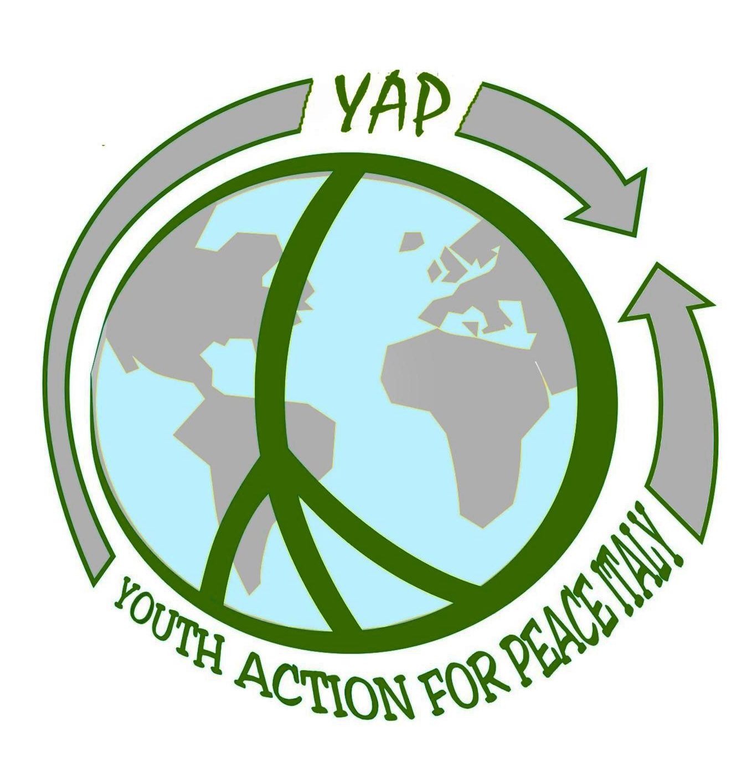
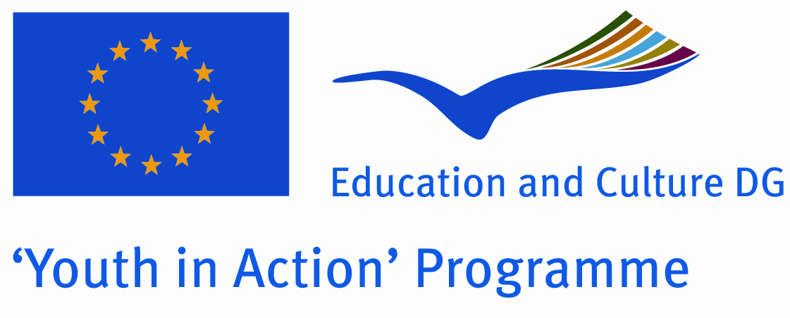 | Action 4 - Youth Support Systems  Sub-Action 4.3 – Training and networking

Project Description

SEEDS OF PARTICIPATION
Urban Gardening for Inclusive Growth and Social Inclusion
Training Course, Action 4.3

Location: San Giorgio a Cremano (NA)

DATES: 15th-20th November 2012 (14/11/2012 ARRIVAL Day, 21/11/2012 DEPARTURE Day)

LOCATION: San Giorgio a Cremano (NA), under the Vesuvio volcano, belongs to the department of Napoli (Naples) and is 8 kilometres far from the centre of the big city. It rises close to the sea level. San Giorgio a Cremano has a population of 52.150 inhabitants about. People in the town enjoy pretty good conditions of life, in spite of being at the boundaries of a big city.

PARTNERSHIP:

YAP (Youth Action for Peace) Italia | Italy
Útilapu Nemzetközi Építőtábor Hálózat | Hungary
VJF (Vereinigung Junger Freiwilliger e.V.) | Germany
UNIVERSITUR Association | Romania
Elix - Conservation Volunteers Greece | Greece
SJ (Solidarites Jeunesses) | France
COCAT - Coordinadora d'Organitzadors de Camps de Treball Internacionals de Catalunya | Spain
Centro informagiovani di San Giorgio a Cremano | Italy

PARTICIPANTS: 3 for each organization

AGE: 18 +

TARGET GROUP: youth workers, peer educators, social workers and volunteers active at local and international level, with past experience in social inclusion and active citizenship.
Particularly welcome will be those who are active in the outskirts of the big cities and that daily work through environmental activities with youth at risk of exclusion.

AIM: the project aims at promoting young people's commitment towards a more inclusive growth. Under this perspective the urban gardens are a powerful tool to stimulate the youth participation, the youth awareness toward the global environmental challenges, the climate change and the active development of "green" skills and behaviours to requalify peripheric and degraded areas.

THEMES:

- Environment: the green skills and in particular the urban gardening will become a operative tool to promote and enhance the social inclusion of youth with fewer opportunities, coming from the outskirts and suburbs of big European cities. The urban garden and the cultural values it bears will become by one hand a way to involve the youngsters in voluntary activities aimed at vitalising suburbs affected by an uncontrolled urbanization and by the other, will permit the specialization of these youngsters and will facilitate their job insertion.

- Urban/Rural development: the project will be set in a Naples suburb called San Giorgio a Cremano which presents some of the typical problems of other European suburbs such as the high level of unemployment, the school abandon, the criminality and the difficulties faced by the public institution to respond adequately to the local needs. Furthermore we expect that all the involved participants will come from (or work on) urban and suburban dimensions, those people have to work with youngsters at higher risk of social exclusion.

The project aims at developing new social inclusion routes able to involve youngsters coming from suburbs, at higher risk of social exclusion and marginalization, at involving them in concrete, deep-rooted actions based on voluntarism and active citizenship and at giving them new tools and knowledge, based on urban gardens and voluntarism, to struggle against the unemployment

In order to meet the general aim of the project, some SPECIFIC OBJECTIVES are identified:
- to set in the different countries involved a deep analysis of the local needs faced by youth at risk of social exclusion;
- to analyse the daily conflicts faced by these youth and to look for non violent ways to face them;
- to promote, through urban gardening, the active participation of these youth to the community life and the sharing of intercultural values;
- to use green skills and in particular urban gardens to involve new young beneficiaries and to transmit them new knowledge and skills on that field;
- to contributes to the development of the quality of support systems for youth activities and the capabilities of civil society organisations in the youth field;
- to share good practices on urban requalification in the different countries;
- to promote concrete actions in suburbs aimed at facilitating urban requalification measures;
- to mobilize youth in new local and internal projects, based on voluntarism, mobility and active citizenship;
- to reduce the youth unemployment and to facilitate the youth job reinsertion;

SUBJECTS OF THE TRAINING: the project will be structured in 2 different sessions

Workshop on social inclusion and inclusive growth
- Young people and suburbs: life conditions, needs analysis;
- Conflicts and their non violent management: sharing good practices and launch of new proposals;
- Sustainability and active citizenship: how to raise awareness on sustainable development among youngsters at risk of social exclusion;
- Inclusive growth as a channel to promote social inclusion and job reinsertion;
- Inclusive growth and voluntarism as a tools to activate young people coming from suburbs;
- Urban gardening and voluntarism as a tools to promote the urban and suburban requalification;
- Voluntarism as tool to make youngsters with fewer opportunities social actors on their local backgrounds and promoters of concrete actions;
- Sharing of good practices among European partners and launch of new proposal to make the project’s effect enduring.

Workshop on urban gardening as a tool to facilitate the social inclusion and to promote the active citizenship:
- Urban gardens as an innovative tool to transmit intercultural values;
- Environment and social inclusion: how to use urban gardens to pass on positive messages based on sharing, respecting and using of urban space, in particular in marginalized backgrounds at risk of social exclusion;
- Urban gardens as space of socialization and involvement: presentation of good practices from different countries;
- Urban gardens in practice: how to create an urban garden using recycling materials;
- Urban gardens as tool to promote social inclusion and job reinsertion;
- Urban gardens and voluntarism: how to empower youth;
- Knowledge transmission: how to pass the skills gained to other youth;
- How to promote enterprising and creativity of youngsters with few opportunities through the setting of urban gardens;
- Youngsters and “green skills”: how sustainable lifestyles and behaviours can be adopted in the daily life of European youngsters.

METHODOLOGIES: during the training an interactive methodology, based on the principles of non formal education, will be proposed (techniques like ice breakers, team building activities, energisers, role play games, will be used). The aim is to stimulate the active involvement of participants, to generate a permanent sharing and to facilitate the mutual exchange of experiences and knowledge.
In each activity, a peer to peer approach will be actively encouraged: trainers and participants will share tools in an horizontal manner in order to guarantee the different learning approaches.

PREPARATORY WORK: before the training participants will be invited to do some preparatory work: they have to bring to the project some books, pictures (analogical or digital) and video concerning urban gardens in their countries
The list with the preparatory work required will be sent soon.

FINANCIAL CONDITIONS:
100% food and lodgement covered by the project
70% travel cost anticipated by the participants and refunded at the end of the project

NOTE: we will refund all the partners after the end of the project as soon as we receive all the documents in original and as soon as we will receive the first instalment from Italian National Agency
Please note the price includes the tickets return (flight + train + bus) second class travels. The taxi cannot be refunded.
The amount specified in the “travel cost for every country” is the 100%, that it will be refunded of the 70% as standard rule of the YiA Programme.
NOTE: Please before booking write us an e-mail and wait for our confirmation.

TRAVEL COST FOR GREECE: 300,00€ (each participant)

